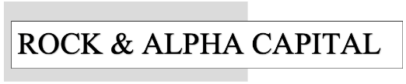

DAILY

REPORT

Tendencies

I am not a licensed investment adviser, and nothing shared in this report constitutes personalized financial, investment, legal, or tax advice. All opinions, analyses, forecasts, and stock ideas are provided solely for informational, educational, and entertainment purposes. While I strive to provide accurate information, I make no guarantees regarding its completeness or accuracy and accept no liability for any losses or decisions made based on this content. Investing involves risk, including the potential loss of capital, and past performance does not guarantee future results. Always conduct your own research and consult a qualified financial adviser before making any investment decisions. All views expressed are my own and are not affiliated with or endorsed by any financial institution.

